- Name | Subject Class | Class | Index  Number
 | 2BIX01



ANGLO-CHINESE JUNIOR COLLEGE
Preliminary Examination 2021

BIOLOGY 8876/02
26 August 2021
HIGHER 1 2 hours

Paper 2 Structured & Free-response Questions
For Examiner's Use
1
2
3
4 or 5
Total | 60

READ THESE INSTRUCTIONS FIRST

Write your name, index number and class on the top of this page.
Write in dark blue or black pen.
You may use a soft pencil for any diagrams, graphs or rough working.
Do not use staples, glue or correction fluid.

Answer all questions in the spaces provided on the Question Paper.
No additional materials are required.

The use of an approved scientific calculator is expected, where appropriate.
You may lose marks if you do not show your working or if you do not use appropriate units.

The number of marks is given in brackets [ ] at the end of each question or part question.

this question paper consists of 13 printed pages.
Section A

Answer all the questions in this section.

- Fig. 1.1 is an electron micrograph of part of a eukaryotic cell.
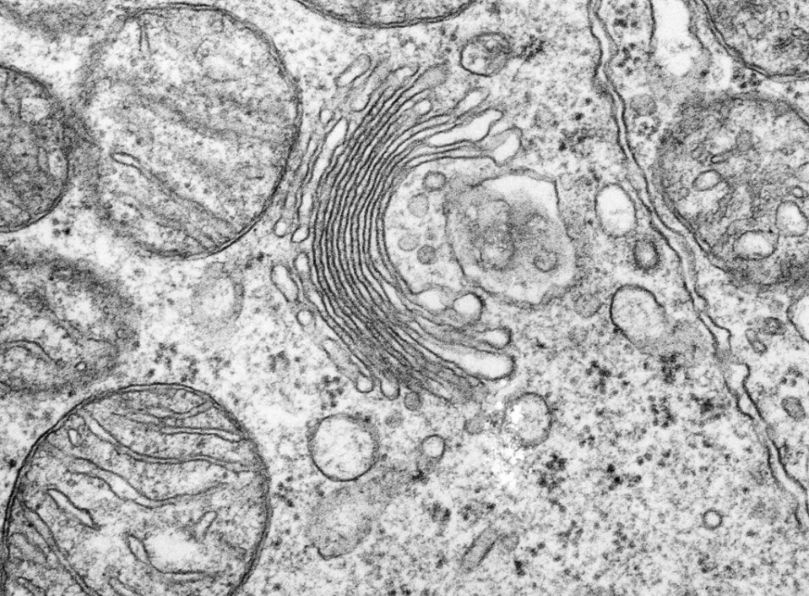

G

Fig. 1.1

(a) Both the Golgi body and the rough endoplasmic reticulum are part of the network of membranes inside cells.

 | (i) | Describe the structural features shown in Fig. 1.1 that identify G as the Golgi body and not the rough endoplasmic reticulum.
 |  |  | [2]

 | (ii) | The nucleus contains genes which code for proteins found in other cellular organelles such as the Golgi body. Substances involved in protein synthesis move in and out of the nucleus. Describe and explain the movement of these substances.
 |  |  | [3]

(b) Outline how proteins are synthesised after the ribosome binds to the mRNA.
[4]

[Total: 9]

- Mangroves are plants that live in freshwater swamps and along salt water shoreline areas as shown in Fig. 2.1. They are mainly found in the tropics and subtropics, acting as nurseries for numerous species of birds, fish, crustaceans and shellfish.

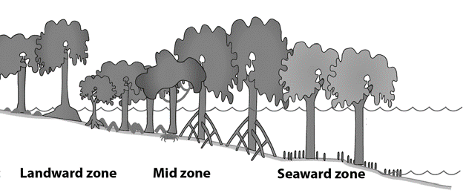
High tide

Mean sea level
Fig. 2.1

Mangroves are able to live in harsh coastal conditions through various adaptations. One such adaption is the ability to grow in low oxygen concentrations in waterlogged mud. Mangroves have lateral roots known as pneumatophores that grow upward out of the mud and water to absorb gases directly from the atmosphere as shown in Fig. 2.2.
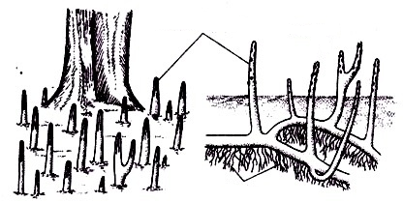
Pneumatophores

Normal roots

Submerged roots

Fig. 2.2

(a) | (i) | Explain how mangrove plants with more pneumatophores are able to yield more ATP per molecule of glucose.
 |  |  | [2]

A group of scientists aims to investigate how well different species of mangroves grow along a river mouth in India. The mean height and total biomass (the amount of living tissue mass of a population) of four mangrove species were recorded as shown in Table 2.1.

Table 2.1

mangrove species | mean height (m) | total biomass (arbitrary units)
Bruguiera gymnorrhiza | 7.28 | 0.510
Lumnitzera racemose | 9.56 | 1.273
Excoecaria agallocha | 8.92 | 0.958
Ceriops tagal | 6.74 | 0.263

 | (ii) | Explain how the products of respiration and photosynthesis contribute to the biomass of plants.
 |  |  | [2]

 | (iii) | Describe the relationship between the mean height and total biomass of mangroves shown in Table 2.1.
 |  |  | [2]

 | (iv) | Suggest whether the mean height or total biomass of mangroves is a more accurate indicator of plant growth and explain your answer.
 |  |  | [2]

 | (v) | Explain how climate change may result in the drowning of mangroves.
 |  |  | [3]

Mangrove forests are good carbon sinks as they absorb more carbon dioxide from the atmosphere than they release. One of the proteins involved in this role is ribulose bisphosphate carboxylase-oxygenase (rubisco) that is found in the chloroplasts of mangroves as shown in Fig. 2.3. Rubisco has an active site that has a complementary 3D configuration to carbon dioxide, allowing the formation of a rubisco-carbon dioxide complex.

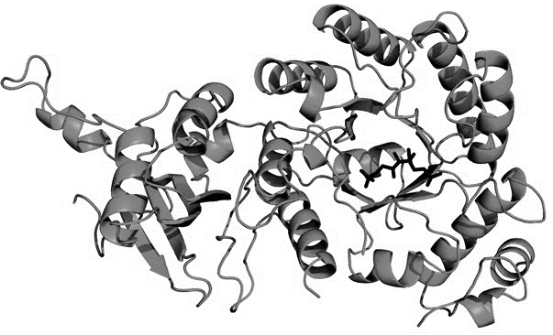

Fig. 2.3

(b) | (i) | State the region in the chloroplast where rubisco is found.
 |  |  | [1]

 | (ii) | Describe the local folding of the polypeptide chain to form regular structures in rubisco.
 |  |  | [2]

 | (iii) | Environmentalists are worried about how mangroves may no longer be an effective carbon sink in light of increased temperatures due to global warming.  With reference to the activity of rubisco, discuss whether the environmentalists’ worries are valid.
 |  |  | [4]

[Total: 18]

- Li-Fraumeni syndrome is a rare hereditary disorder that is associated with cancer development.

The disorder arises due to a mutation in the TP53 tumour suppressor gene occurring in germline cells. Scientists have made the following observations about the disorder:

- The TP53 gene is located on chromosome 17.
- Individuals with Li-Fraumeni syndrome are heterozygotic at birth, inheriting one copy of the mutated TP53 gene from one parent, and a normal copy from the other parent.

Fig. 3.1 shows the estimated probability of individuals with Li-Fraumeni syndrome being diagnosed with cancer in their lifetime when compared to normal individuals. Fig. 3.2 tracks a particular family’s history for cancer due to Li-Fraumeni syndrome.

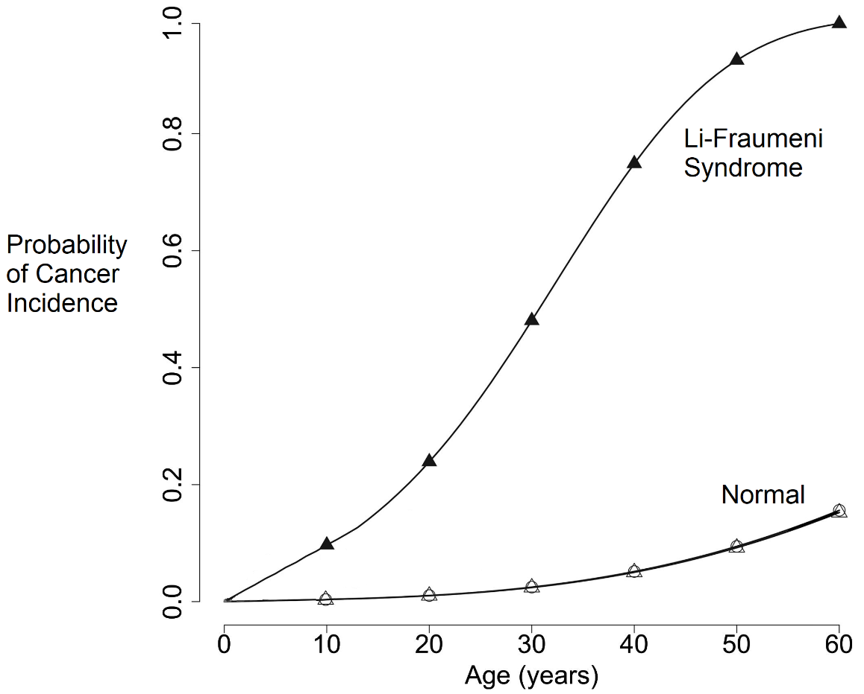

Fig. 3.1

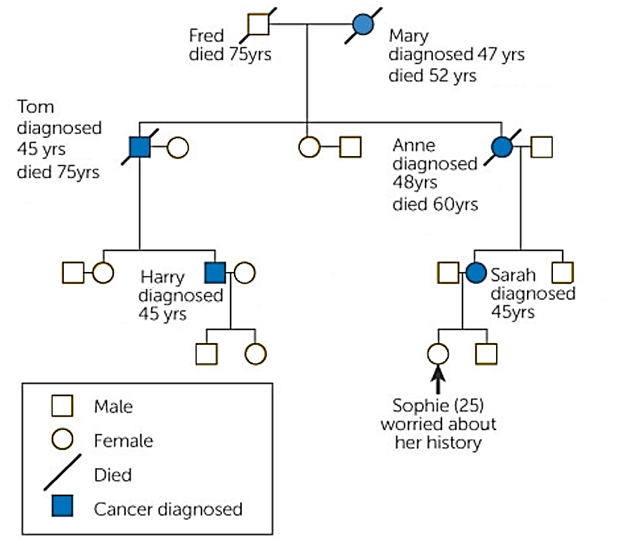
Fig. 3.2

(a) (i) Define what is meant by the term ‘germline cells’.
[1]

(ii) With reference to Fig. 3.1, describe how Li-Fraumeni syndrome affects an individual’s probability of developing cancer.
[3]

Cancer development as a result of Li-Fraumeni syndrome is described as having an autosomal dominant inheritance.

(iii) Based on the information provided, explain how this mode of inheritance can be deduced.
Autosomal:
Dominant:
[2]

The TP53 gene codes for a protein that controls the transcription of other genes involved in the following functions:

- Repair of damaged DNA.
- Arresting the division of cells with damaged DNA.
- Initiating programmed cell death of cells with DNA that cannot be repaired.

It is known that one normal copy of the TP53 gene codes for sufficient proteins to maintain the functions listed above.

(iv) Explain how an individual who inherits one copy of the mutated TP53 gene may develop cancer in his lifetime.
[5]

Researchers explored using a technique known as gene therapy to treat patients with Li-Fraumeni syndrome, as shown in Fig. 3.3. Stem cells were removed from the patient, and a normal copy of the TP53 gene is inserted into the extracted stem cells. The genetically-corrected cells are re-introduced back into the patient.

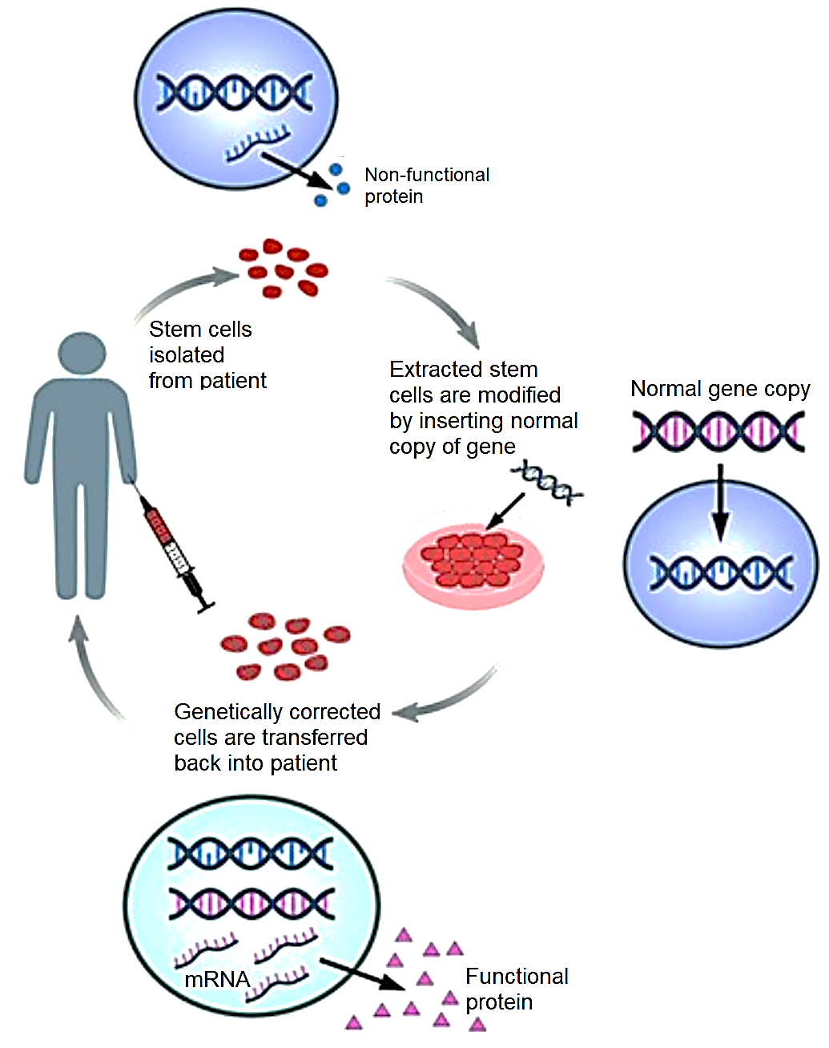

Fig. 3.3

(b) (i) Identify the type of stem cell extracted from the patient and describe the features of this stem cell.
[4]

(ii) Comment on the ethical aspects of the gene therapy used to treat patients with Li-Fraumeni syndrome.
[3]

[Total: 18]

Section B

Answer one essay question.

Write your answers in the writing paper provided.
Your answers should be illustrated by large, clearly labelled diagrams, where appropriate.
Your answers must be in continuous prose, where appropriate.
Your answers must be set out in sections (a), (b) etc., as indicated in the question.

4 | (a) | Describe the structure of a typical bacterial cell and suggest how bacteria secrete proteins in the absence of an endomembrane system. | [6]
 | (b) | Explain how meiosis plays a role in the continuation and evolution of the human population. | [9]

5 | (a) | Carbohydrates may form part of another biological molecule’s structure. Explain the various roles of carbohydrates in these biological molecules. | [6]
 | (b) | Using named examples, explain how genetic variation (including harmful recessive alleles) may be preserved in a natural population. | [9]

[Total: 15]

END OF PAPER

